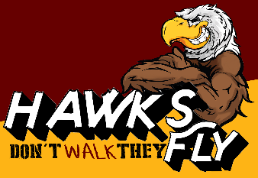
H.A.W.K.S.
H | Have you read the question?  Do you need to read the passage? | -write yes/no I need to read the passage
A | Annotate the question | -circle & define the important words
W | What are the silly answers? | -eliminate 2 incorrect answer choices
K | 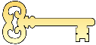  Three is KEY! Reread question and move on | Read! Read! Read!
S | Select the correct answer and justify your answers | Choose the correct answer and explain why it is correct

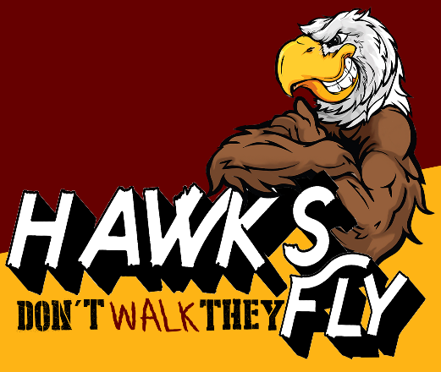
H ave you read the question?

A nnotate the question
What are the silly answers?
K Three is KEY! Reread the question and move on
Select the correct answer and justify your answers

